Lesson plan CLIL
Topic : cooking lesson
Grade: mixed
Assistant teacher: Dana Csomová
Duration : 90 minutes
1. vocabulary – look at the pictures and try to connect them with signs and then try to translate them what they mean in Slovak:
grate – slice, cut –
peel – whisk –
boil – bake –
stir, mix – taste –
add – roll –
pour - whip –
serve – baking tray –
bowl - wooden spoon –
2. Reading and baking
Read the recipe. Do you understand everything in the recipe? O.K. let’s do it!!!
3.writing and listening: Listen to the song, look at the paper , there are some missing words , fill the gaps with words you hear. Are there any words you do not understand?
4. Reading and speaking
Read the article , answer this questions :
Do you help your mum with cooking?
Have you ever baked a cake with your mum?
What is your favourite recipe or food?
Where can you find recipe?
Do you think helping your parents can make them happy?
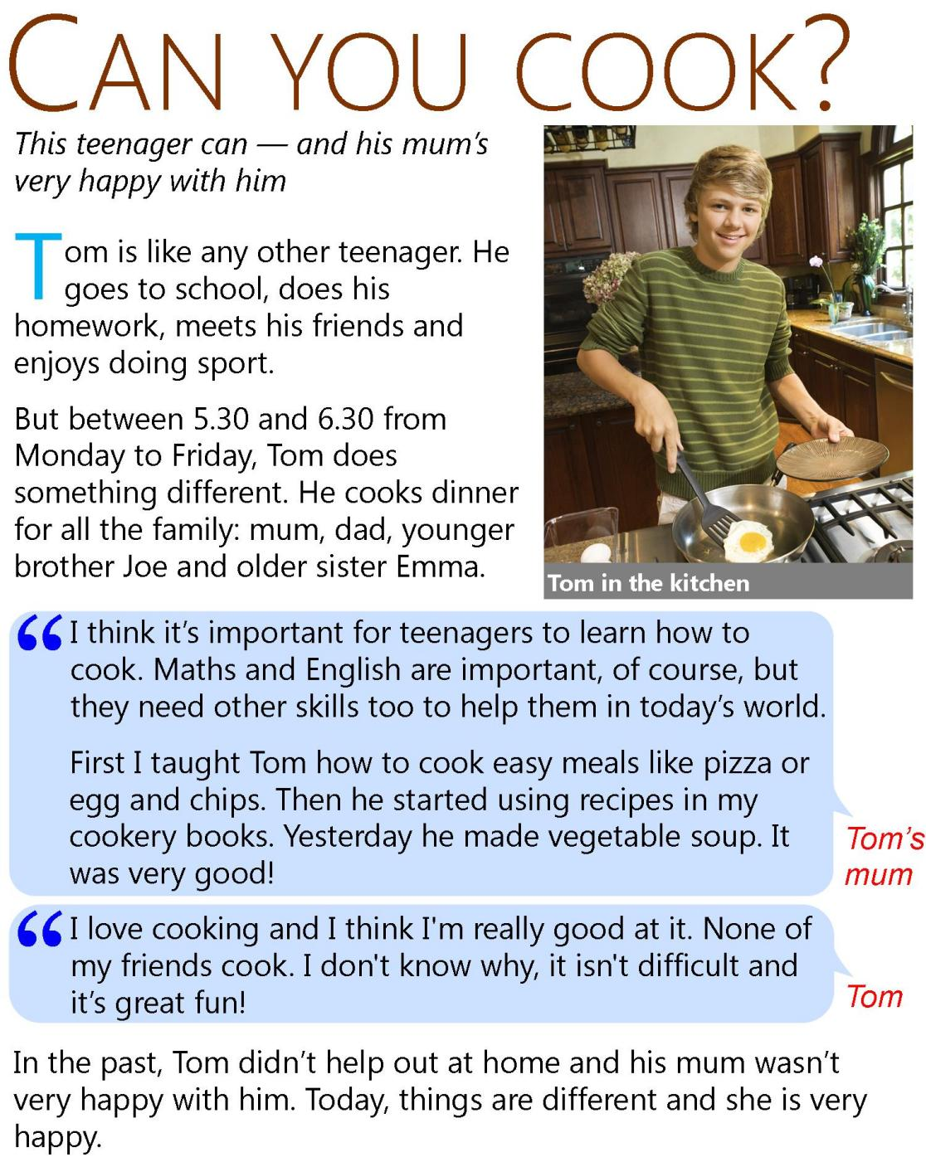

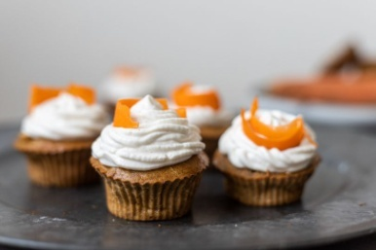
CARROT MUFFINS

INGREDIENTS :
200g caster sugar
200g flour
2 teaspoon ground cinnamon
1 teaspoon baking powder
1 teaspoon baking soda
1 teaspoon salt
3 eggs
120ml oil
200g grated peeled carrots
100g chopped walnuts

CREAM:
250g white chocolate
250g mascarpone
200ml whipped cream

DIRECTIONS:
Step 1 : Preheat the oven to 180 degrees C.
Step 2 : In a bowl mix together all dry ingredients well.
Step 3 : In another bowl mix together eggs and sugar until smooth.
Step 4 : Then add oil and mix until smooth and creamy.
Step 5 : Add dry ingredients and carrots and mix it well.
Step 5 : Pour into the baking tray and put into oven.
Step 6 : Bake for 15 – 20 minutes.
Step 7 : Leave the cake to cool down and then spread the top of the
muffins with the cream

Cooking in the kitchen

Put your apron on , ____________ your hands
Let’s get out some pots and _____________
Cups, plates and a _________________
Tap,tap,tap, a little cooking tune
Cos _______________ in the kitchen is so much ___________
We’re cooking dinner for everyone.
We‘re cooking in the the kitchen, baking a ______________
So many yummy things we can make.
Cook cook cook - cooking in the kitchen
Cook cook cook - cooking in the kitchen.
Cook cook cook – cooking in the kitchen
____________ it , stir it , __________ mix mix.
Let’s mix up a ____________ of goo
With a little bit of water and flour too
Stir it up until it’s nice and thick
Then put it in the __________ for one minute...
Yay!
Cos cooking in the kitchen is so much fun
We’re cooking dinner for everyone.
We‘re cooking in the the kitchen, baking a cake
So many yummy things we can make.
Cook cook cook - cooking in the kitchen
Cook cook cook - cooking in the kitchen.
Cook cook cook – cooking in the kitchen
Stir it , stir it , mix mix mix.

