CLIL lesson – 3.
Subject: ENGLISH/MUSIC
Teachers: Mgr. Polozsányiová Evelyn
Class: 5.A
Lenght of lesson: 90 minutes
Topic: Types of musical instruments

Teaching methods: Teacher-Centered Instruction, whole class work, pair work and individual work, practical learning
Training aids: work sheets from Super Minds 3 work book, musical instruments - castanets, violin, interactive dvd, data projector, internet ( Youtube )
Educational goals: The main goal is to teach students to listen to different sounds that instruments make, to be able to categorize musical instruments of different types based on their characteristics
Vocabulary:
wind instruments - dychové nástroje
stringed instruments - sláčikové nástroje
percussion instruments - bicie nástroje
to blow - fúkať
rhythm – rytmus
strings – struny
trombone - trombón
flute - flauta
cello - violončelo
drum - bubon
recorder - zobcová flauta
guitar - gitara
piano - klavír
castanets - kastanety
triangle - triangel

The structure of the lesson:
1. motivation discussion and instruction
2.explaining and revising different types/ ´´families´´ of musical instruments on the board and writing down as many examples as possible to each one of them
3. after careful revising, the students are given a worksheet, where they need to identify and subsequently match the musical instruments to their types ´´families´´
4. Students need to guess the musical Instruments based on the sounds they hear in the video and choose the correct one from three given options
5. students are given another worksheet, where they need to count the musical instruments and write down sentences with There is/ There are. In the next exercise they need to correct the amount of instruments based on the families they belong to
6. interactive games via dvd – various activities connected to the topic ( categorizing, matching and identifying the musical instruments... )
7. Bonus activity – one of the students plays a song on violin, the others can try playing the castanets
Source: https://www.youtube.com/watch?v=4knAhsh7Ksc

Main activity: blending the knowledge of musical instruments with joy of playing them, connecting theory with artistic experience
Evaluation/Assesment: the worksheets were checked in pairs or together, the other activities were evaluated orally and students received immediate feedback
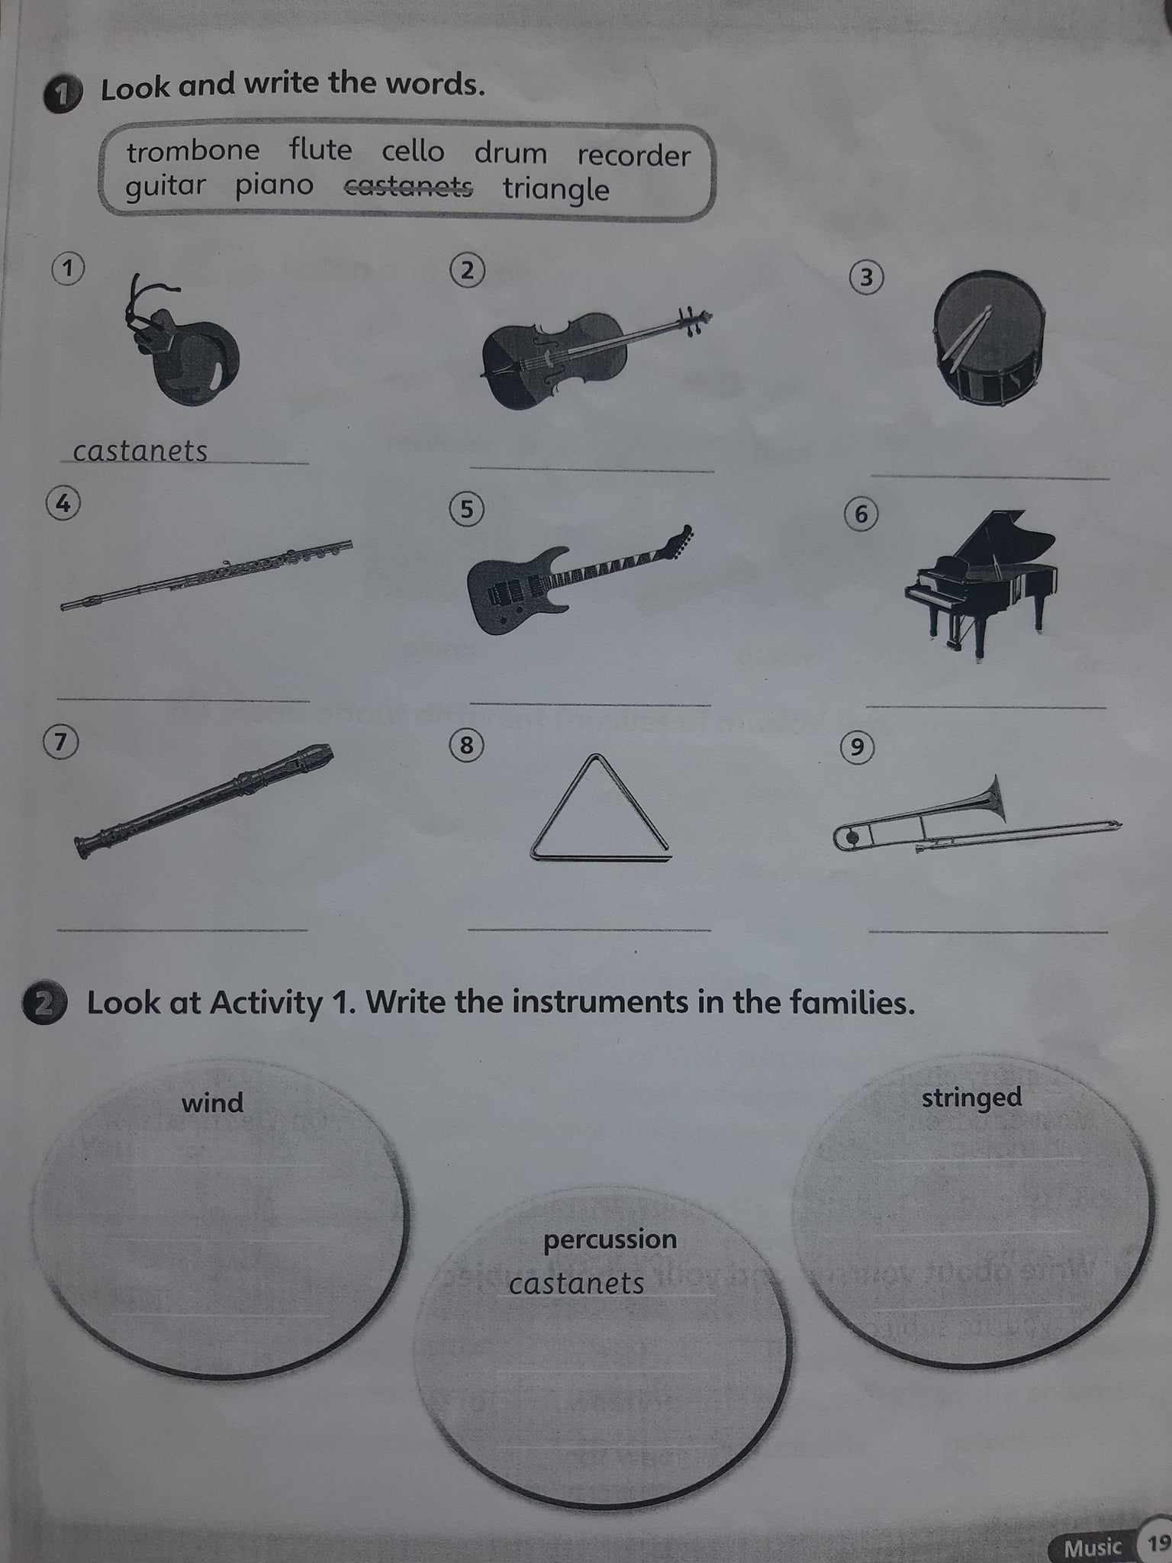
Worksheets with tasks:
