CLIL lesson – 6.
Subject: ENGLISH/Science
Teachers: Mgr.Králiková Lucia and PaeDr.Ildikó Foldesová (Science teacher)
Class: 9.A/Dutch students and Dutch teachers for jobshadowing
Lenght of lesson: 90 minutes
Topic: chemical reactions

Teaching methods: Teacher-Centered Instruction, Cooperative Learning, practical learning
Training aids: different chemicals and dissolutions, tools used in lab
Educational goals: The main goal is to teach students to work in groups and to find out and proof some chemical reactions
Vocabulary:
CARBOHYDRATES-SACHARIDY
SIMPLE or MONOSACCHARIDES-JEDNODUCHÉ
COMPOUND/COMPLEX-ZLOŹENÝ- those with 2 or more units are called oligosaccharides
those with more than 10 inits are called poly saccharides
REAGENT-ČINIDLO
MORTAR-MAŹIAR
GAUZE-GÁZA
BEAKER-KADIČKA
The structure of the lesson: 1.motivation discussion
2.students divided into groups and drawing a task
3.reading text in English and understanding it
4.practical observation and work in lab
5.drawing and writing the chemical reaction in worksheets
6.presentation of each group a their results
Main activity: working in groups and showing our guest from The Netherlands how we implement clil lessons during our teaching practice, 5 teachers came for jobshadowing
Evaluation/Assesment: each group´s presentation was evaluated oraly and positives were picked –up
MATERIALS STUDENTS WORKED WITH:
Theory:
Carbohydrates are natural organic substances. We devide them into monosacharides, oligosacharides and polysaccharides.

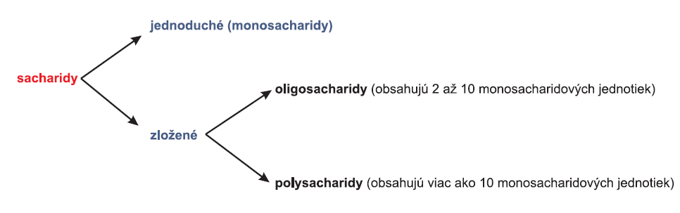
Monosaccharides are: glucose, fructose, galactose and mannose
Oligosacharides are: disaccharides like sucrose, lactose, maltose
Polysaccharides: starch, glycogen, cellulose, chitin
TASK 1: Fehling ´s test
TASK 2: Proof of starch
Chemicals: Fehling's solution: Fehling's solution I (7 g of CuSO4.5H2O in 100 cm3 of water), Fehling's solution II (35 g of sodium potassium tartrate + 10 g of NaOH in 100 cm3 of water).

Lugol's solution:
preparation:
1 g of iodine,
2 g of potassium iodide,
300 ml of distilled water
Tools:
test tubes,
test tube stands,
burner,
knife,
spoon,
orange,
honey,
granulated sugar,
potato
Approach:
1. Prepare 2 stands. Place 4 test tubes in each.
2. Squeeze the juice from the orange and prepare a solution of orange juice (if it is not enough, dilute it with water).
3. Dissolve a teaspoon of honey in 50 ml of water.
4. Dissolve a teaspoon of sugar in 50 ml of water.
5. Cut the potato, scrape off the mushy mass with a knife (scalpel) and add a little water.
6. Pour 2 ml of orange juice solution into the 1st test tube in the first rack.
7. Pour 2 ml of honey solution into the 2nd test tube in the first stand.
8. Pour 2 ml of sugar solution into the 3rd test tube in the first rack.
9. Pour 2 ml of potato juice solution into the 4th tube in the first rack.
10. Pour 2 ml of orange juice solution into the 1st test tube in the second rack.
11. Pour 2 ml of honey solution into the 2nd test tube in the second stand.
12. Pour 2 ml of sugar solution into the 3rd test tube in the second rack.
13. Pour 2 ml of potato juice solution into the 4th tube in the second rack.
14. Add Fehling's solution to the test tubes in the first rack and heat carefully in a water bath.
13. Drop Lugol's solution into the test tube in the second stand. We observe.
Observation:
GLUCOSE,FRUCTOSE,SUCROSE,STARCH
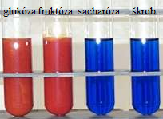
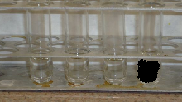
After Fehling's reagent was added, the orange juice solution and the honey solution were first decolorized. After adding Lugol's solution, only starch became darkly colored in the second row.

Conclusion:
The resulting red-brown precipitate is copper oxide. During the reaction, the saccharide was oxidized and the copper was reduced. Glucose in orange juice and fructose in honey are reducing carbohydrates. Sucrose in sugar and starch in potato did not give a positive reaction.
A positive reaction of starch with iodine is used in practice to prove iodine in substances.
TASK 1: DNA ISOLATION
TOOLS AND CHEMICALS: filter apparatus, gauze, spoon, fork, beaker, whisk, pipette, strawberries, pineapple juice, salt, ethanol, cleaning agent
WORKING PROCEDURE:
! Work on task 2 while you are waiting!
VOCABULARY:
mortar-mažiar
gauze- gáza
beaker- kadička
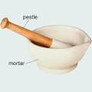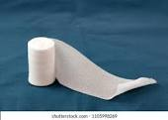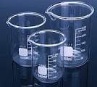
1. Use a fork to mash 3-4 strawberries in a mortar.
2. Using a pipette, add 5 ml of water and a teaspoon of salt.
3. Mix the mixture well and add a teaspoon of detergent. Wait 5 min.
4. Filter the mixture, use gauze or fabric as a filter.
5. Add 3 to 5 ml of pineapple juice to the filtrate and wait 5 min.
6. Pour approximately the same amount of ethanol into the mixture along the walls of the beaker.
7. After 2-3 minutes, draw the result.
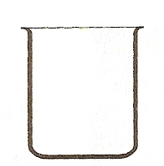

OBSERVATION:
TASK 2: BLIND TABLE
The basic building block of NK is a nucleotide:
Correctly put the elements that make up the nucleotides into the PSP.
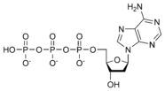
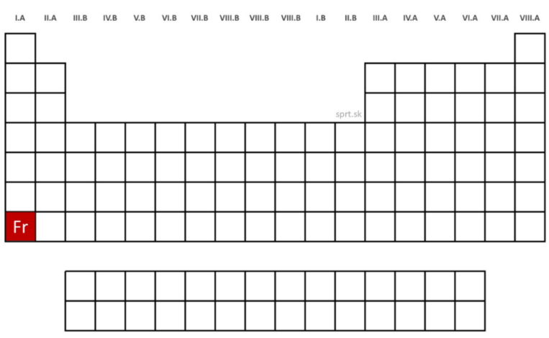
Photos taken during the lesson in the lab:
